Finecause - Characteristics of Contact Lens and Rubber Pads
Finecause - Characteristics of Contact Lens and Rubber Pads

1.Finecause provides fast and accurate new molding process. New pads will be
completed within 7 days after confirmation of the drawings. completed.
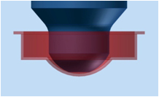
2.Negative pressure value reaches 2 TOLL and above when
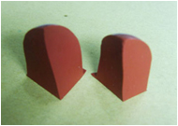
Finecause Rubber Pad Other Rubber pad
3.We developed the silicone with characters that suits the best for
contact lens ink and with even color.
4.We inspect every single pad produced for its straightness.
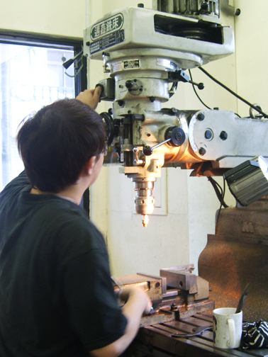
5.After pad de-molding process, there is no deckle edge for the center hole.
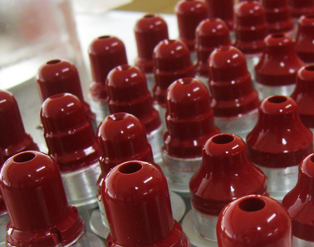
6.Quality control of the adhesion for rubber pad and metal aluminum base.
7.Strict quality control of the Rubber Pad cleanliness.
8.Leading techniques and quality in the industry with competitive prices.
